Department of Computer Science

Gujarat University

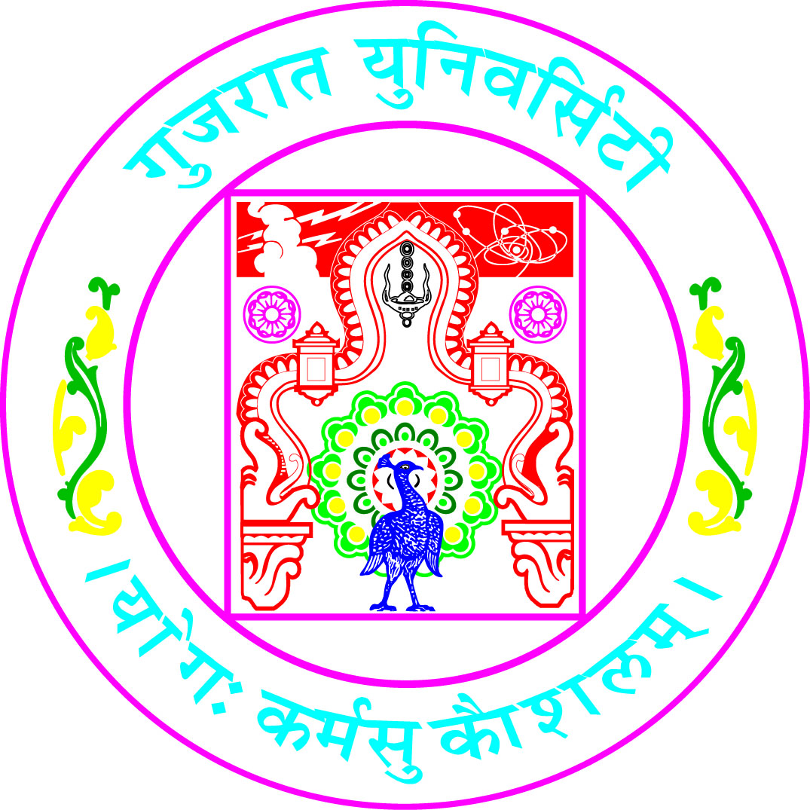

Certificate

Roll No: 13 Seat No:__50002___

This is to certify that Mr./Ms. ______Antra koul__________________ student of MCA Semester – V has duly completed his/her term work for the semester ending in December 2020, in the subject of ___Wireless Communication and Mobile Technology______ towards partial fulfillment of his/her Degree of Masters in Computer Applications.

22-12-2020
Date of Submission Internal Faculty

Head of Department

